CPSC 240: Computer Organization and Assembly Language

Assignment 01, Fall Semester 2023

CWID:__885857847_______________ Name:Kush Patel________________________

1. Download the “CPSC-240 Assignment01.docx” document.
2. Follow the “CPSC-240 Ex01 Hello World.pdf” slide to design a “hello.asm” Assembly program and generate. “hello.o”, “hello.lst”, and “hello” files.
3. Copy and paste the “hello.asm” file into the document.
4. Follow the “CPSC-240 Ex01 Debugger.pdf” slide to debug the “hello” file.
5. When the program runs to line 12, copy and paste the "Register" window into the document.
6. When the program runs to line 18, copy and paste the "Register" window into the document.
7. When running the "x/14db &text" and "x/s &text" commands, copy and paste the "DDD" window (including the gdb panel) into the document to display the memory results.
8. Save the file in pdf format and submit the pdf file to Canvas before deadline.
9. Deadline is 23:59 pm on 09/06/2023.

[Insert hello.asm file here]

; ex hello.asm

; char text[] = "Hello, World!\n"

; cout << text;

section .data

        text db "Hello, World!", 10

section .text

        global _start

_start:

         mov rax, 1

         mov rdi, 1

         mov rsi, text

         mov rdx, 14

         syscall

         mov rax, 60

         mov rdi, 0

         syscall

[Insert 1st Register window here]

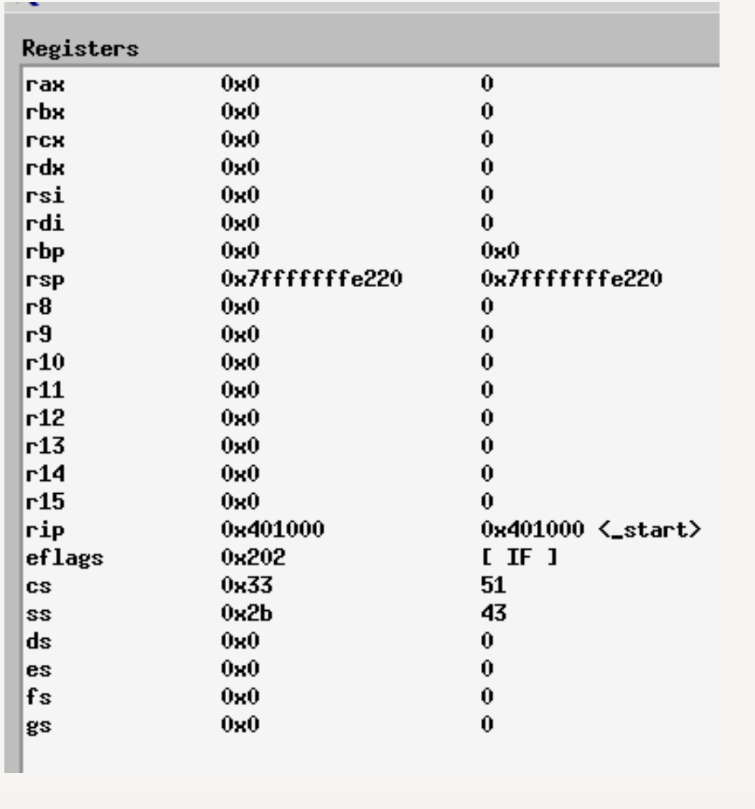

[Insert 2nd Register window here]

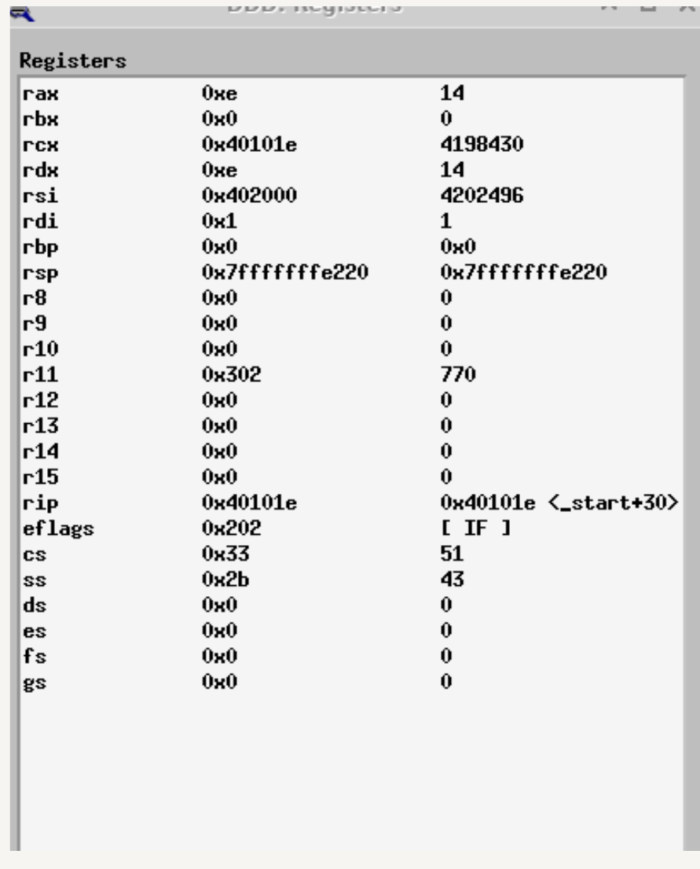

[Insert DDD window here]

